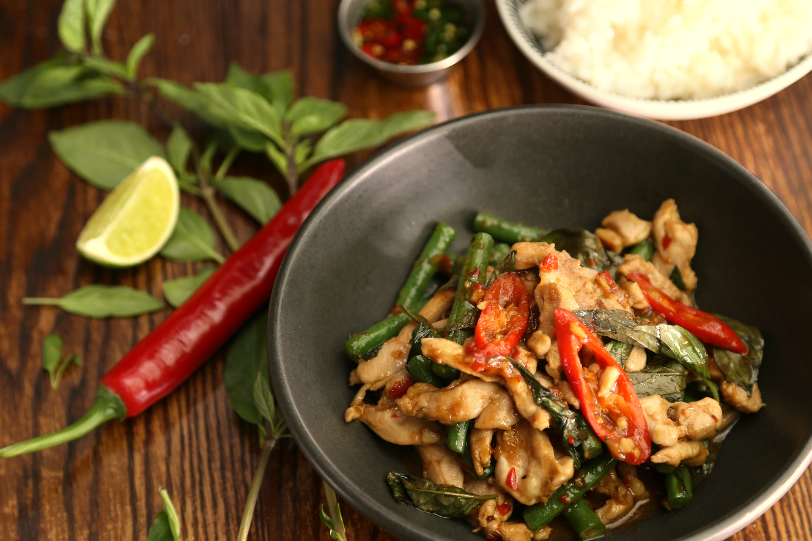

**Evergreen**

**Thai Restaurant**

**L.L.B.O**

***Healthy, Home-Style, Thai Food***

**Business Hours**

Mon-Fri: 11am-11pm

Sat: 11am-10pm

Sun: 3pm-10pm

**Address**

175 Dundas St .West, Toronto, ON, M5G 1C7

**Order Takeout**

416.581.8668

evergreenthai.com

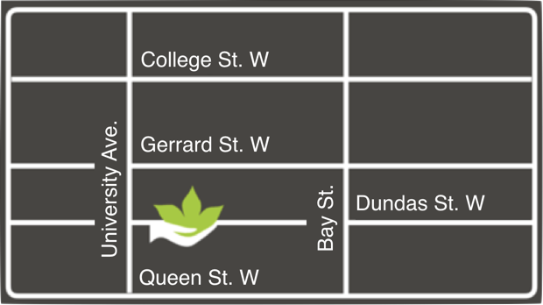

**COMBO SPECIALS**

**Lunch 13.00***served with spring roll, salad & soup*

**Dinner 15.00***served with dumpling, salad & soup*

1 Pad Thai Chicken ✭

2 Bangkok Stir Fried Chicken ✭

3 Thai Fried Rice Chicken or Beef ✭

4 Basil Fried Rice Chicken or Beef ✭

5 Red Curry Rice Chicken or Beef ✭

6 Cashew Chicken or Beef with Rice ✭

7 Basil Chicken or Beef with Rice ✭✭

8 Mango Chicken with Rice ✭

9 Spicy Eggplant with Rice ✭

10 Golden Tofu with Rice ✭

11 Panang Tofu with Rice ✭

12 Spicy Fish with Rice (+1.00) ✭

✭  **Substitute Shrimp (+1.00)**

✭ **Brown Rice (+1.25)**



416.581.8668

*evergreenthai.com*

**Lunch: 11am-4pm Dinner: 4pm-close**

**APPETIZERS**

**A1 Veggie or Taro Crispy Spring Roll (2 pcs)**  3.00

**A2 Chicken or Shrimp Crispy Spring Roll (3 pcs)**  5.00

**A3 Veggie Fresh Cold Roll (1 pc)**  3.00

**A4 Shrimp Fresh Cold Roll (1 pc)**  3.50

**A5 Edamame**  3.00

**A6 Crispy Calamari**  6.50

**A7 Crispy Tofu (6 pcs)**  4.00

**A8 Spicy Garlic Shrimp** 8.00

**A9 Honey Squid** 7.00

**A10 Chicken Satay (4 skewers)**  6.50

**A11 Chicken Wings (4 pcs)**  6.50

**A12 Pan-Fried Dumplings (6 pcs)**  5.00  
 *12 pcs (+4.00)*

**A13 Fish Cake (4 pcs)**  6.00



416.581.8668

*evergreenthai.com*

Evergreen

**SALAD**

**S1 Mango Salad**  6.00  
*green mango, lettuce, tomato, carrot, peanut with fresh lemon sauce. add grilled chicken (+3.00)*

**S2 Garden Salad**  1.75

**S3 Avocado Salad**  5.00

**S4 Seaweed Salad**  5.00

**S5 Papaya Salad** 7.00

**SOUP**

*Tom Yum Soup. Served with carrot, green onion, bean sprout, mushroom, coriander*

***Regular Large***

**T1 Hot & Sour Shrimp Soup** 🌶️🌶️ 5.00 6.50

**T2 Chicken Lemongrass Soup** 4.506.00

**T3 Chicken Coconut Milk Soup** 4.75 6.25



416.581.8668

*evergreenthai.com*

Evergreen

**FRIED RICE**

**F1 Thai Fried Rice***carrot, onion, pepper, pineapple, tomato, egg*Chicken or Beef 10.25Shrimp 11.25

**F2 Basil Fried Rice***carrot, onion, pepper, basil, egg*Chicken or Beef 10.50Shrimp 11.50

**F3 Seafood Fried Rice**  11.50*shrimp, squid, mussel, basil, egg, crab paste*

**F4 Golden Fried Rice** 11.25*chicken, shrimp, carrot, onion, pea, egg, curry sauce*

**F5 Japanese Fried Rice** 11.50*shrimp, squid, crab meat, carrot, onion, pepper*

**STIR FRIED NOODLE**

**M1 Pad Thai***rice noodle, carrot, green onion, bean sprout, tofu, egg, peanut with tamarind sauce*Chicken or Beef 10.75Shrimp 11.75

**M2 Bangkok Stir Fried (Glass Noodle)***bean vermicelli, carrot, pepper, broccoli, green onion, bean sprout, tofu, egg, peanut with Thai mild sauce*Chicken or Beef 10.75Shrimp 11.75

**M3 Pad Sew***thick rice noodle, choi-sum, egg with soy sauce*Chicken or Beef 10.75Shrimp 11.75

**M4 Basil Noodle***rice noodle, basil, carrot, green onion, bean sprout, mushroom, egg*Chicken or Shrimp 12.00

**M5 Golden Noodle***rice noodle, carrot, pepper, bean sprout, egg, curry sauce*Chicken or Shrimp 12.00

**M6 Siam Noodle***rice noodle, carrot, onion, pepper, broccoli, mushroom, egg*Chicken or Shrimp 12.00

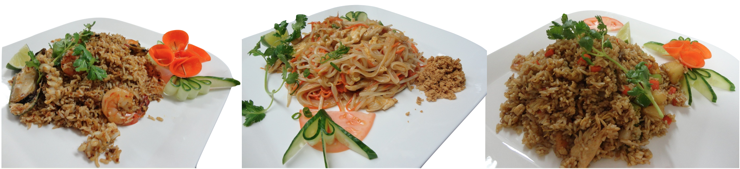

Evergreen

**THAI CURRY**

Served with Jasmine Rice. Substitute Brown Rice (+1.25).

**Regular Large**

**C1 Green Curry** 🌶️🌶️*eggplant, onion, pepper, broccoli, basil*Chicken or Beef 12.00 13.50Shrimp or Fish 13.00 15.00

**C2 Golden Curry***potato, carrot, onion, pineapple, bay leaf*Chicken or Beef 12.00 13.50Shrimp or Fish 13.00 15.00

**C3 Red Curry** 🌶️ *bamboo shoot, basil, carrot, pepper, broccoli*

Chicken or Beef 12.00 13.50Shrimp or Fish 13.00 15.00

**C4 Panang Curry Chicken** 🌶️ 13.00*broccoli, green bean, pepper, peanut, lime leaf*

**C5 Golden Curry Lamb** 15.00*New Zealand lamb, carrot, basil, potato*

**NOODLE SOUP**

**N1 Thai Noodle Soup (Tom Yum Soup)**🌶️*rice noodle, carrot, green onion, bean sprout, tomato, mushroom, coriander.* ***add coconut milk (+1.00)***Chicken or Shrimp 10.00

**N2 Country Noodle Soup (Chicken Broth)**  
*rice vermicelli, onion, green onion, celery, tofu, choi-sum*Chicken or Shrimp 10.00

**WOK**

Served with Jasmine Rice. Substitute Brown Rice (+1.25).

**W1 Basil***basil, carrot, onion, pepper, broccoli*Chicken or Beef 11.00Shrimp 12.00

**W2 Cashew***cashew nut, carrot, onion, pepper, Chinese cabbage*Chicken or Beef 11.00Shrimp 11.50

**W3 Ginger***ginger, carrot, onion, pepper, celery, bok choi*Chicken or Beef 11.00Shrimp 12.00

**W4 Peanut***carrot, onion, pepper, mushroom with peanut sauce*Chicken or Beef 10.75Shrimp 11.75

**W5 Sesame***carrot, onion, pepper, pea with sesame sauce*Chicken or Beef 10.25Shrimp 11.25

**W6 Spicy Lime Leaf** 🌶️*lime leaf, carrot, onion, pepper, eggplant, green bean with spicy sauce*Chicken or Beef 11.00Shrimp 12.00

**W7 Mango Chicken or Beef** 11.00*mango, carrot, onion, pepper with mango sauce*

**W8 General Thai** 11.00*breaded chicken, pineapple, tomato, carrot, onion, pepper with sweet & sour sauce*



416.581.8668

*evergreenthai.com*

**VEGETABLES**

Served with Jasmine Rice. Substitute Brown Rice (+1.25)

**V1 Spicy Eggplant**🌶️🌶️10.50*eggplant, basil, onion, pepper, black bean sauce.* ***add chicken (+1.50)***

**V2 Spicy Tofu**🌶️10.25  
*fried tofu, lime leaf, onion, pepper, cashew nut, mushroom, green bean, spicy sauce*

**V3 Golden Tofu** 10.50  
*fried tofu, onion, pepper, carrot, mushroom, broccoli, golden curry sauce*

**V4 Panang Tofu**🌶️🌶️10.50  
*fried tofu, green bean, pepper, peanut, broccoli, panang curry sauce*

**V5 Basil Tofu** 9.75  
*fried tofu, basil, green bean, pepper, broccoli, basil sauce*

**V6** **Mixed Vegetables** 9.75  
*carrot, broccoli, onion, lettuce, mushroom, bok choi.* ***add tofu (+1.00)***

**SEAFOOD**

Served with Jasmine Rice. Substitute Brown Rice (+1.25)

**H1 Seafood Combination**  14.00  
*shrimp, squid, mussel, scallop, onion, pepper, broccoli, green bean, celery, ginger*

**H2 Spicy Shrimp**🌶️ 13.00  
*shrimp, carrot, pepper, broccoli, mushroom, baby corn, green bean, spicy sauce*

**H3 Spicy Squid**🌶️ 12.50  
*squid, bamboo shoot, basil, onion, pepper, carrot, lime leaf*

**H4 Spicy Fish**🌶️ 12.50  
*fried fish fillet, basil, onion, pepper, carrot, lime leaf, spicy sauce*

**H5 Sweet & Sour Fish**  12.00  
*fried fish fillet, onion, pepper, carrot, sweet and sour sauce*

**H6 Basil Mussel**  13.50  
*mussel, basil, onion, pepper, carrot, lime leaf, bok choi*



416.581.8668

*evergreenthai.com*

Evergreen

**SET DINNER**

Served with Jasmine Rice. Substitute Brown Rice (+1.25)

**D1 Dinner for Two** 38.00*2 Veggie Spring Rolls  
Mango Salad  
2 Chicken Lemongrass Soup  
Pad Thai Shrimp  
Thai Chicken Curry with Rice  
Green, Golden or Red  
Ice Cream*

Served with Jasmine Rice. Substitute Brown Rice (+1.25)

Evergreen



**Evergreen**

**Thai Restaurant**

**L.L.B.O**